PROGRAMMING TASKS FOR LAB # 01

TASK # 01:
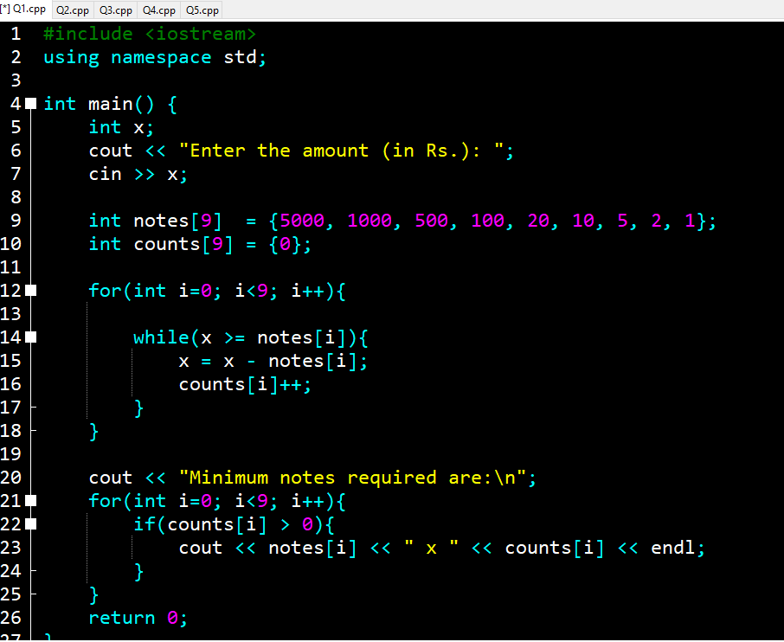
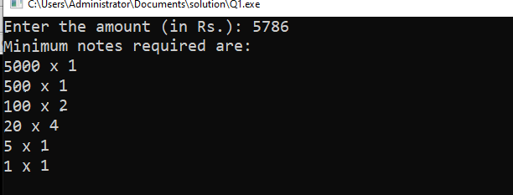
TASK # 02
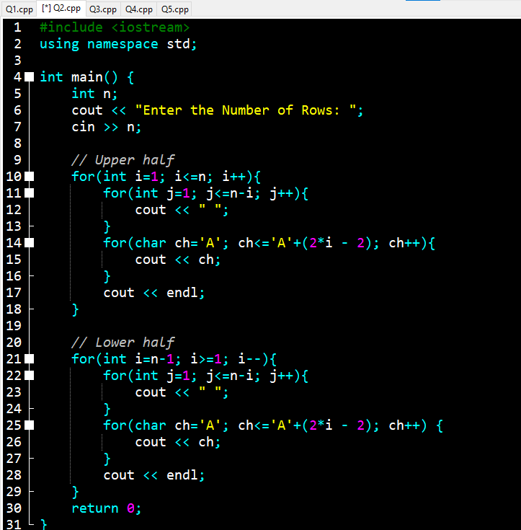
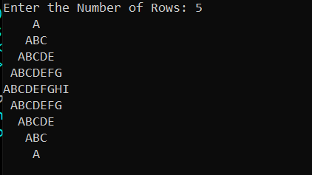
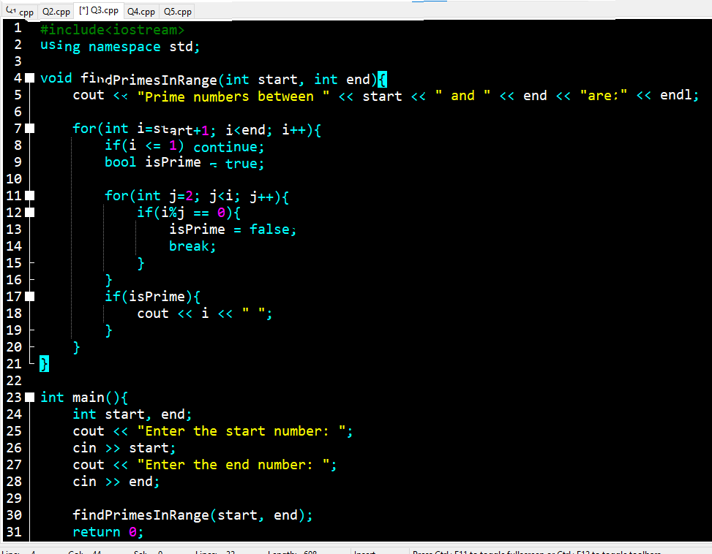
TASK # 03

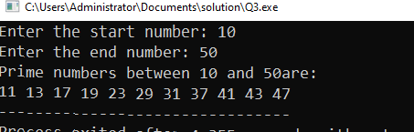
TASK # 04
#include<iostream>
#include<climits>
using namespace std;
int main(){
int size;
cout << "Enter size of arrays: ";
cin >> size;
int array1[size], array2[size];
cout << "First array values: ";
for(int i=0; i<size; i++){
cin >> array1[i];
}
cout << "Second array values: ";
for(int i=0; i<size; i++){
cin >> array2[i];
}
//2. Swapping arrays
for(int i=0; i<size; i++){
int temp = array1[i];
array1[i] = array2[i];
array2[i] = temp;
}

cout << "Arrays after swapping:" << endl;
cout << "First array: ";
for(int i=0; i<size; i++){
cout << array1[i] << " ";
}
cout << "\nSecond array: ";
for(int i=0; i<size; i++){
cout << array2[i] << " ";
}
//3. The largest element
int max = array1[0];
int index = 0;
for(int i=1; i<size; i++){
if(max < array1[i]){
max = array1[i];
}
}
cout << "\nLargest element in first array (after swapping): " << max << endl;
//4. Second largest element
int largest = INT_MIN, second_max = INT_MIN;
for(int i=0; i<size; i++){
if(array2[i] > largest){
second_max = largest;
largest = array2[i];
}
else if(array2[i] > second_max && array2[i] != largest){
second_max = array2[i];
}
}
cout << "Second largest element in second array (after swapping): " << second_max << endl;
//5. Unique element
int unique = array1[0];
for(int i=0; i<size; i++){
bool isUnique = true;
for(int j=0; j<size; j++){
if(i!=j && array1[i] == array1[j]){
isUnique = false;
break;
}
if(isUnique){
cout << "Unique element in first array (after swapping): " << array1[i] << endl;
break;
}
}
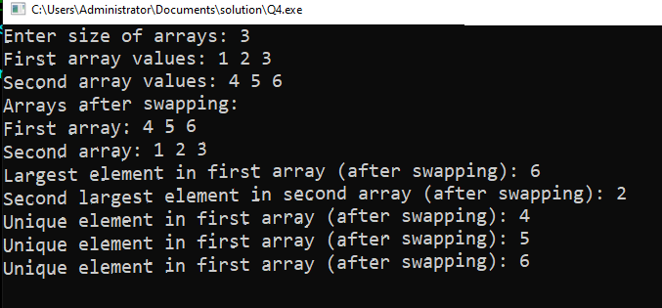
}
return 0;
}

TASK # 05
#include <iostream>
using namespace std;

void multiplyMatrices(int A[][10], int B[][10], int C[][10], int m, int n, int p);

int main() {
int m, n, p, q;

cout << "Enter rows and columns of the first matrix: ";
cin >> m >> n;
cout << "Enter rows and columns of the second matrix: ";
cin >> p >> q;

// Multiplication rule
if(n != p) {
cout << "Error: Matrix multiplication not possible!" << endl;
cout << "Number of columns in first matrix (" << n
<< ") must equal number of rows in second matrix (" << p << ")" << endl;
return 0;
}

//(using max size 10x10 for simplicity)
int A[10][10], B[10][10], C[10][10];

// Input matrices
cout << "\nEnter elements of the first matrix:" << endl;
for(int i = 0; i < m; i++) {
for(int j = 0; j < n; j++) {
cin >> A[i][j];
}
}
cout << "\nEnter elements of the second matrix:" << endl;
for(int i = 0; i < p; i++) {
for(int j = 0; j < q; j++) {
cin >> B[i][j];
}
}

// Multiply matrices
multiplyMatrices(A, B, C, m, n, q);

// Display result
cout << "\nResultant Matrix after Multiplication:" << endl;
for(int i = 0; i < m; i++) {
for(int j = 0; j < q; j++) {
cout << C[i][j] << " ";
}
cout << endl;
}

return 0;
}

// Function to multiply two matrices
void multiplyMatrices(int A[][10], int B[][10], int C[][10], int m, int n, int q) {
// Initialize result matrix to 0
for(int i = 0; i < m; i++) {
for(int j = 0; j < q; j++) {
C[i][j] = 0;
}
}
// Perform multiplication
for(int i = 0; i < m; i++) {
for(int j = 0; j < q; j++) {
for(int k = 0; k < n; k++) {
C[i][j] += A[i][k] * B[k][j];
}
}
}
}
